Hunter-Bellevue School of Nursing 60 West Classroom Technology
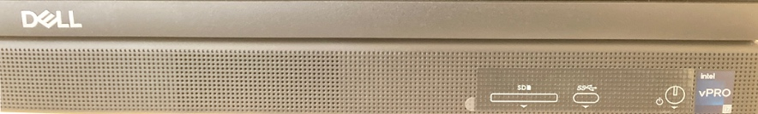
Dell Desktop
- Make sure monitor is turned on. Press the (circle icon) button located under the desktop.
- Type in your Hunter NetID username and password to log into desktop.

Projector Switch
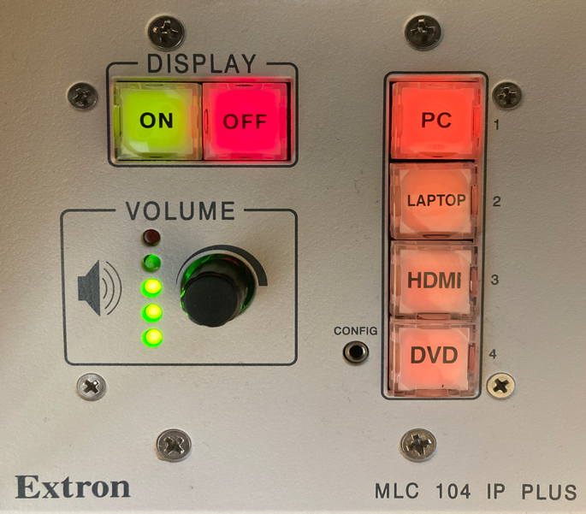
- Press ON
- Make sure PC is selected (default setting)
- Wait 10-12 seconds for screen to begin appearing
- Select desired source
- PC
- Laptop (VGA)
- HDMI
- DVD
- Adjust the volume by slowly turning the knob
clockwise (to increase volume) or counterclockwise
(to decrease volume). You will notice the green
lights come up on the circles under volume
control and you will see a red light when you reach the maximum volume.

Turn Off
A. Turn monitor off by pressing the same circle button located under the desktop.
B. Press OFF on the projector switch.
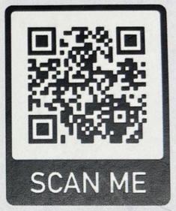
Need Help with AV Equipment, call HPEC 212 481-5129 or stop by Room 614.
Need help with your NETID, scan QR code to the left or contact HelpDesk 212 772-4357.


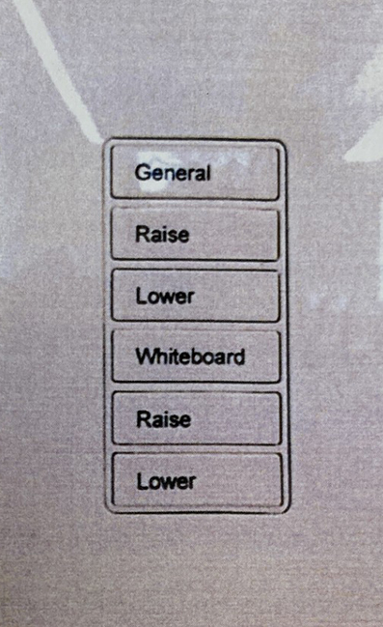
Classroom Lighting
Most classrooms have the wall light switch pictured to the right.
Press “General” to turn on and off the main lighting in the classroom.
Press “Whiteboard” to turn on or off the light facing the whiteboard.
Raise and Lower may be pressed and held to adjust the light intensity for
either the main lighting or whiteboard light.

Additional lighting controls are shown below. “Zone 1” or “Scene 1” should be used to turn on full lighting in the room.
